2026
User Manual
Federated Learning System Demo for Server & Client
Mingyang XUE (20617494) Jiale QIN (20616174)
Table of Contents
1. Prerequisites 2
2. Quick start 2
3. How to use core functions 2
4. Common questions and solutions 4
5. Glossary of terms 4

1. Prerequisites
- Operating System：Windows 10/11
- Running Environment：Python 3.6+

2. Quice start
2.1 Install dependencies
Run below code:
‘’pip install torch>=1.9.0 torchvision>=0.10.0 flwr>=1.0.0 numpy>=1.21.0 matplotlib>=3.4.0 phe>=1.4.0’’
2.2 Running the System
We will take the example of having multiple clients connected to a server on the same machine in parallel. Please run
“python app.py --port xxxx”
in different terminals. Each server and client needs to open an app. You can make the app run on different ports by modifying the port number. Please note that on the same device, avoid starting multiple apps on the same port.
3.3 Open the website
Open http://localhost:xxxx (change to your port number) in the browser

3. How to use core functions
- Start FL Training (Server)
  - In server page, click Start training
  - Expected result: Server shows training status and begins coordinating clients.
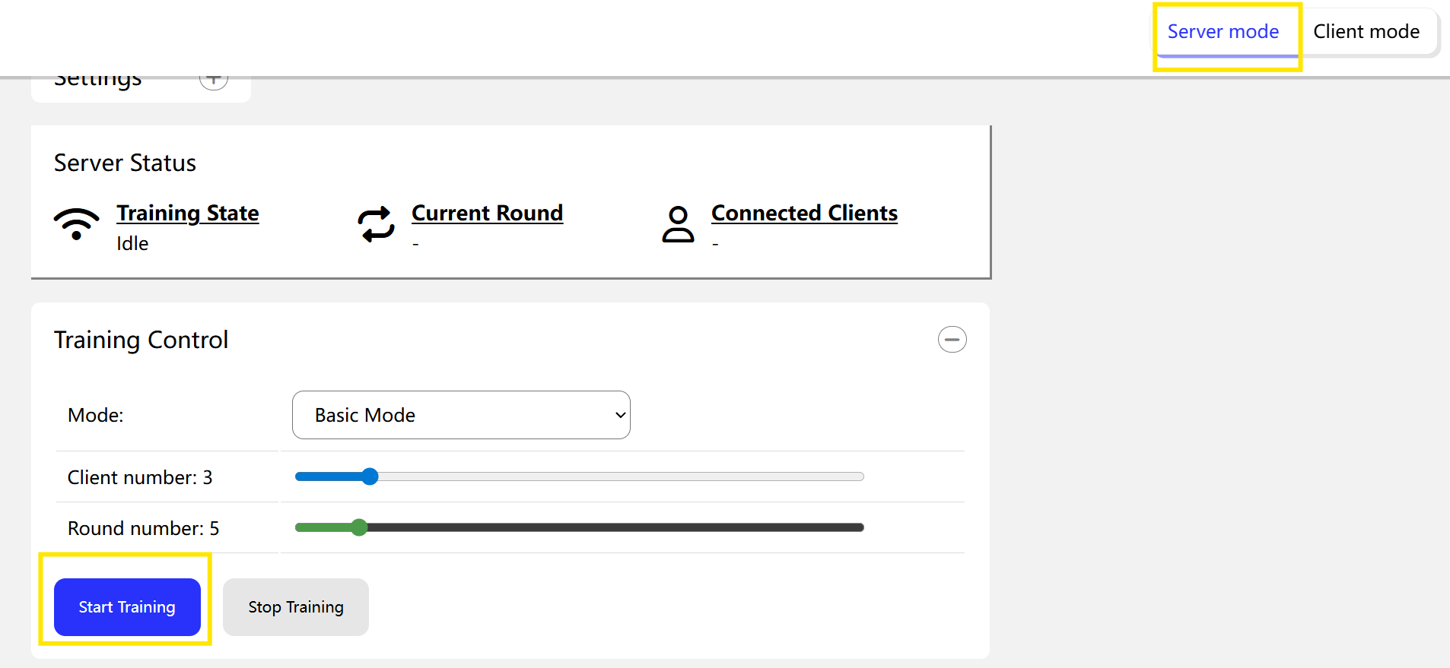
- Start FL Training (Clients)
  - In client page, click Start training on each client page
  - Expected result: clients connect to the server and training progress updates (UI/terminal).
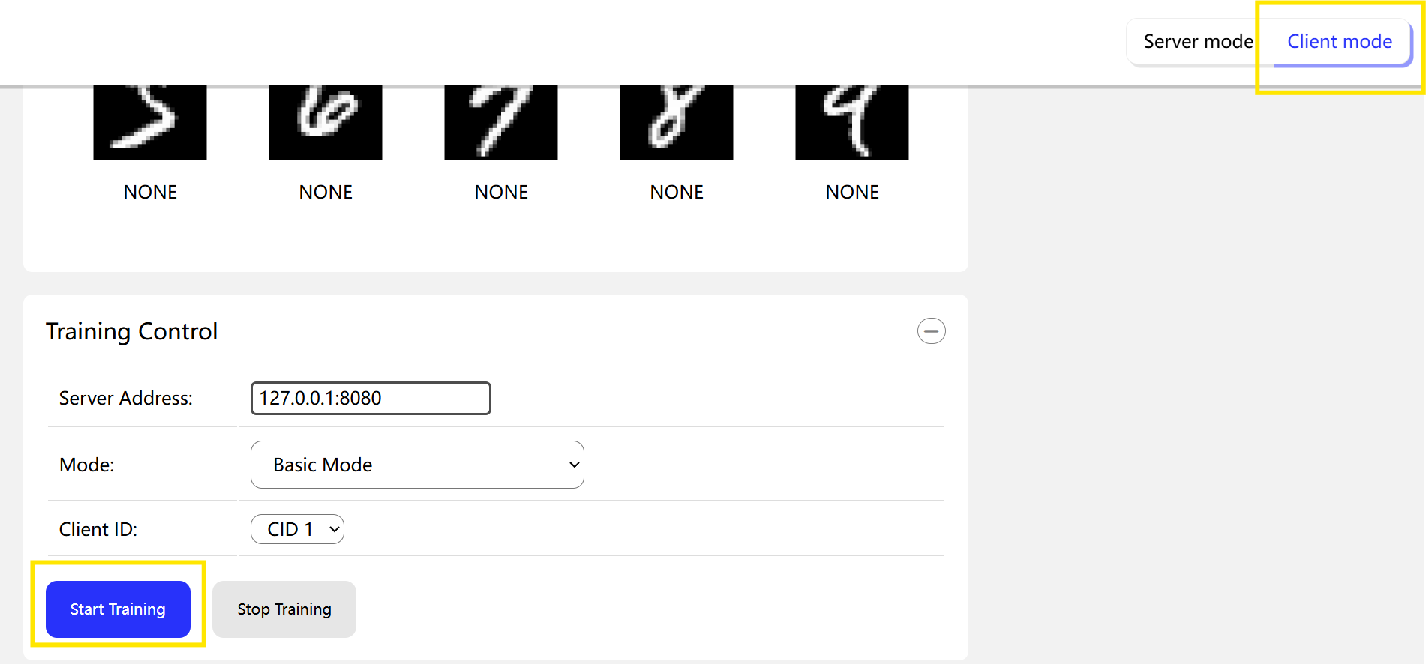
- Switch Mode
  - Click dropdown arrow next to ‘Basic Mode’ to switch to different modes.
  - Expected result: the UI/feature behaviour changes according to the chosen mode.
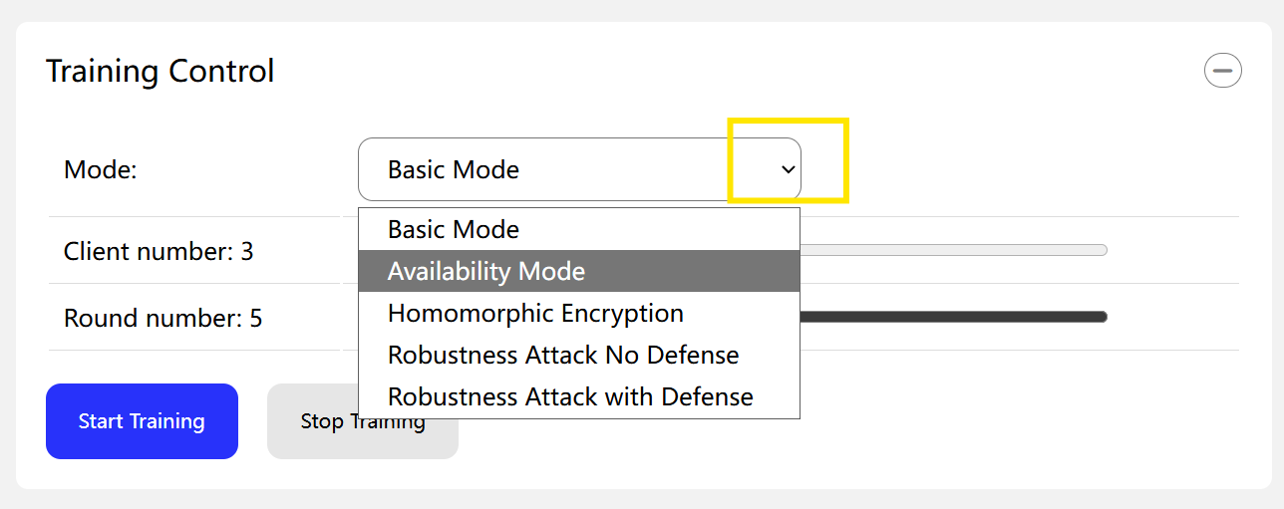

4. Common questions and solutions
  - Clients disconnected
    - Make sure the server has started.
    - Check the server address is correct.
    - Check the Internet connection.
    - Check the firewall settings to ensure that the ports are not occupied.
  - Server crash
a) Refresh the server and start training again.

5. Glossary of terms
Relevant parameters of the training:
‘--num-clients’ the number of clients
‘--num-rounds’ the number of training rounds
‘--use-he’ whether to enable homomorphic encryption
‘--use-defense’ whether use the defense mechanism (MAD + reputation system)
‘--use-random-disconnection’ whether use random disconnect to simulate.
‘--use-history’ whether use historical updates to mitigate the impact of disconnections
‘--disconnect-prob’ probability of server disconnection
‘--max-stale-rounds’ the longest duration of consecutive and intermittent states
‘--he-encrypt-ratio’ the proportion of homomorphic encryption
’--he-mask-seed’ the seeds used in the homomorphic encryption
‘--port’ the port number of front end application
’

